LAB EXPERIMENT RECORD
SET 12: WEBSITE TRAFFIC ANALYSIS
Department | AIDS
Course Code / Course Name | DSA0601 / Data Handling and Visualization
Experiment | Data Visualization using R
Name | B. Pallavi
Register Number | 192424243
Date | 06 October 2026
Day | Monday

Aim
To visualize website traffic data using a line chart, bar chart, and website traffic table, and to build an interactive dashboard using R and Tableau.
Dataset: Website Traffic
Date | Page Views | Click-through Rate
2023-01-01 | 1500 | 2.3%
2023-01-02 | 1600 | 2.7%
2023-01-03 | 1400 | 2.0%

PROGRAM 1: Line Chart of Daily Page Views
Create a line chart to visualize the trend in daily page views over time. Label the axes and title the chart.
R Code
# Dataset
date <- as.Date(c("2023-01-01",
"2023-01-02",
"2023-01-03"))
page_views <- c(1500, 1600, 1400
# Line Chart
plot(date, page_views,
type = "o",
xlab = "Date",
ylab = "Page Views",
main = "Daily Page Views Trend",
pch = 19)
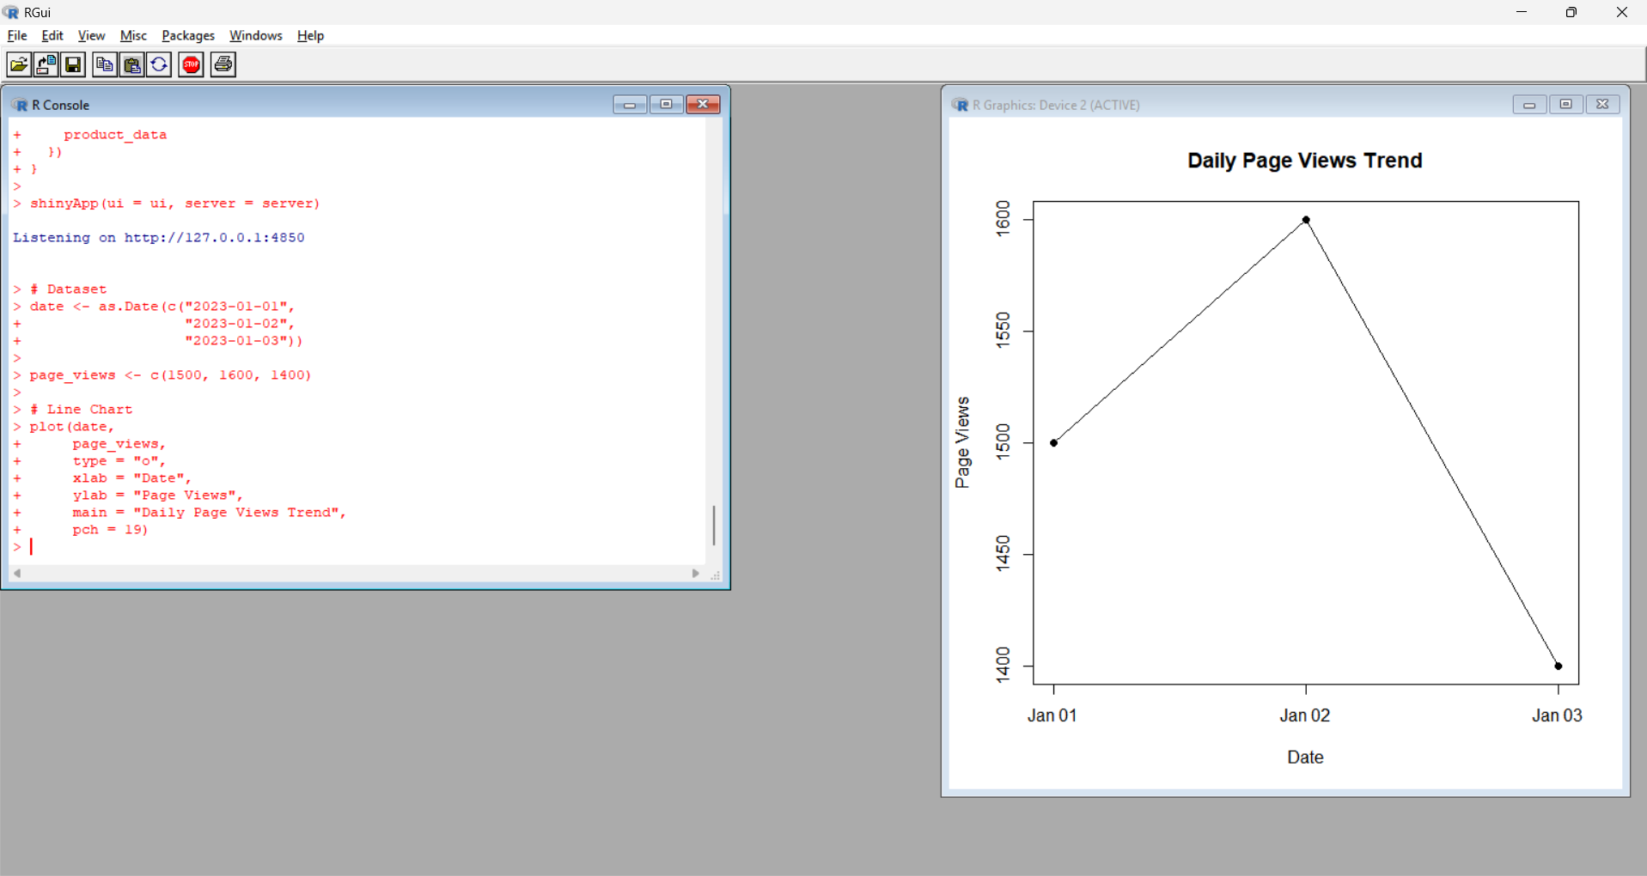
Output 1: Daily Page Views Trend
Observation:
The line chart shows the trend in daily page views. Page views increased from 1500 on January 1 to 1600 on January 2, and then decreased to 1400 on January 3.
PROGRAM 2: Bar Chart of Top N Click-through Rates
Generate a bar chart showing the top N days with the highest click-through rates. Label the chart elements.
Since the dataset contains only three days, N = 3 is used.
R Code
# Dataset
date <- as.Date(c("2023-01-01",
"2023-01-02",
"2023-01-03"))
click_rate <- c(2.3, 2.7, 2.0)
# Create data frame
traffic_data <- data.frame(
Date = date,
Click_Through_Rate = click_rate
)
# Sort by click-through rate
traffic_sorted <- traffic_data[
order(-traffic_data$Click_Through_Rate), ]
# Select top 3 days
top_n <- head(traffic_sorted, 3)
# Bar Chart
barplot(top_n$Click_Through_Rate,
names.arg = format(top_n$Date, "%Y-%m-%d"),
xlab = "Date",
ylab = "Click-through Rate (%)",
main = "Top N Days by Click-through Rate",
col = "skyblue")
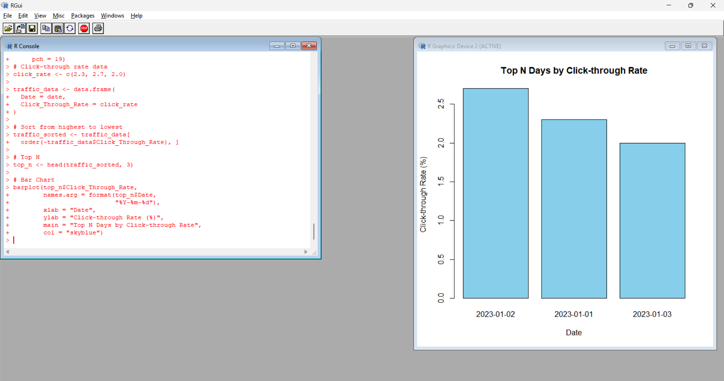
Output 2: Top N Days by Click-through Rate
Observation:
The bar chart shows that 2023-01-02 has the highest click-through rate of 2.7%, followed by 2023-01-01 with 2.3% and 2023-01-03 with 2.0%.
PROGRAM 3: Website Traffic Table
Build a table to show the website traffic data for each day. Label the table elements.
R Code
# Website Traffic Data
website_data <- data.frame(
Date = as.Date(c("2023-01-01",
"2023-01-02",
"2023-01-03")),
Page_Views = c(1500, 1600, 1400),
Click_Through_Rate = c("2.3%", "2.7%", "2.0%")
)
# Display Table
print(website_data)
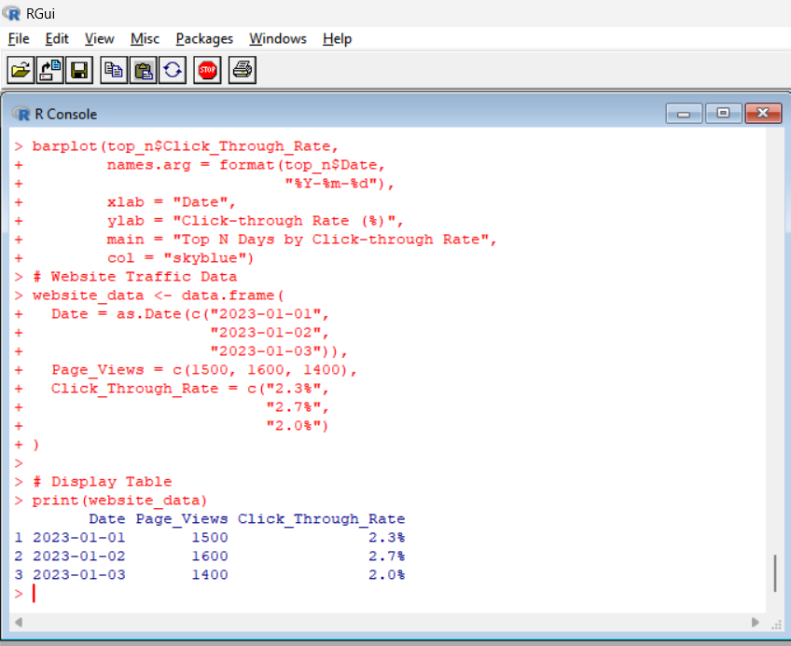
Output 3: Website Traffic Table
Date | Page Views | Click-through Rate
2023-01-01 | 1500 | 2.3%
2023-01-02 | 1600 | 2.7%
2023-01-03 | 1400 | 2.0%
Observation:
The table displays complete website traffic information for each day, including page views and click-through rate.
PROGRAM 4: Interactive Website Traffic Dashboard
Develop a Tableau dashboard combining the line chart, bar chart, and the table for interactive exploration of website traffic data.
Dataset for Tableau
Create an Excel file with the following data:
Date | Page Views | Click-through Rate
2023-01-01 | 1500 | 2.3%
2023-01-02 | 1600 | 2.7%
2023-01-03 | 1400 | 2.0%
Save the file as:
Website_Traffic.xlsx
Tableau Steps
- Open Tableau.
- Select Microsoft Excel.
- Open Website_Traffic.xlsx.
- Select Sheet 1.
- Drag Date to Columns.
- Drag Page Views to Rows.
- Select Line from the Marks card.
- Drag Page Views to Label.
- Rename the sheet Daily Page Views Trend.
- Create a new worksheet.
- Drag Date to Columns.
- Drag Click-through Rate to Rows.
- Select Bar from the Marks card.
- Drag Click-through Rate to Label.
- Sort the bars from highest to lowest.
- Rename the sheet Top N Click-through Rates.
- Create a new worksheet.
- Drag Date, Page Views, and Click-through Rate to the view.
- Select Text Table.
- Rename the sheet Website Traffic Table.
- Click New Dashboard.
- Drag Daily Page Views Trend into the dashboard.
- Drag Top N Click-through Rates into the dashboard.
- Drag Website Traffic Table into the dashboard.
- Set the title as Website Traffic Analysis Dashboard.
- Select Use as Filter to make the dashboard interactive.
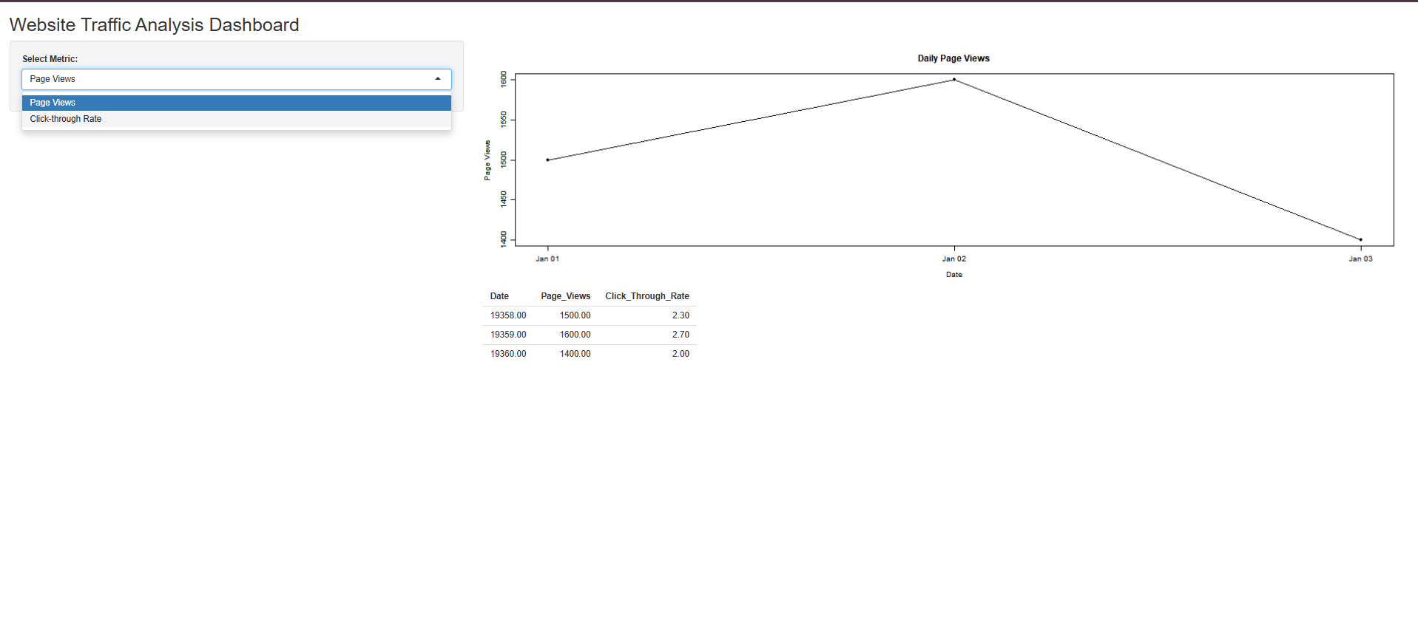
Output 4: Website Traffic Analysis Dashboard
Observation:
The dashboard combines daily page view trends, click-through rate information, and detailed website traffic data into a single interactive view. It allows users to compare daily website performance and explore traffic information.
Procedure
- Create date, page views, and click-through rate vectors in R.
- Use plot() to create the daily page views line chart.
- Sort the click-through rates using order().
- Use barplot() to generate the top N click-through rate chart.
- Create a data frame to display website traffic information.
- Create an Excel file containing website traffic data.
- Connect the Excel file to Tableau.
- Create the daily page views line chart.
- Create the top N click-through rate bar chart.
- Create the website traffic table.
- Combine all three views into an interactive dashboard.
Result
The website traffic data was successfully visualized using a line chart, bar chart, and website traffic table. An interactive Tableau dashboard was also created to display and explore website traffic information.

